* **Demo**. a working, ***deployed***, version of the app, that shows the ***complete set***of final client facing features
* **License Choice**. explain which license your team and client ***agreed to*** for the app and why it was chosen
* **User Testing Results**. one positive ***and*** one critical thing learned from user testing your app with potential users (including user quotes is encouraged).  
  Share one thing ***each person*** learned during the semester from interacting with potential users

Positive: the app have clean UI design and its userful

* “very clean UI, liked how the add appointment is the main focus on navigation”
* “Easy to use, can view timeline easily and record and get very accurate transcript. I love it!”

Critical thing learned from user: improve usability

* Add an * for required fields when adding appointment information
* Less words on recording screen and bigger button
* **Testing Results**. demo the results from running your automated tests, ***showing Code Coverage results***, and describe one manual test you do regularly as well as results from an Accessibility checking tool.  
  Share one thing ***each person***learned or changed by testing their code regularly.

Automated Tests:

Code Coverage:

C:\Users\xusiy\Desktop\Fall 2020\app_cornelius\backend\cornelius_app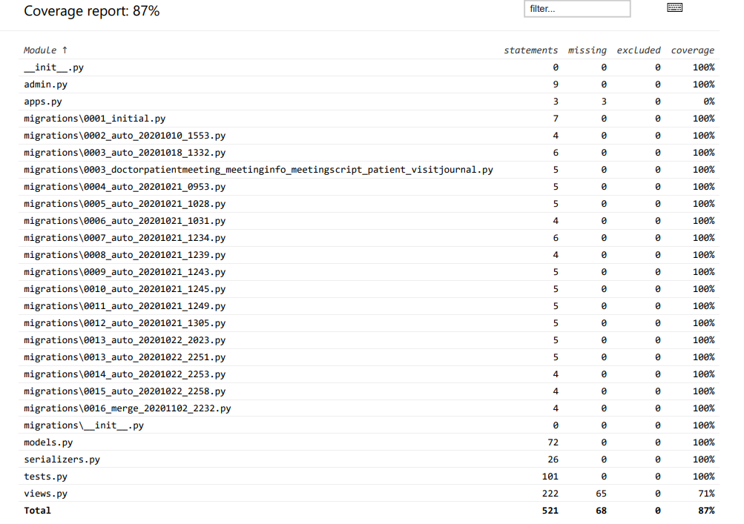

Manually test: https://cool-wharf-291516.ue.r.appspot.com/meeting/pid1/

* **App Review**. ***contrast*** the completed app compared to where you planned it to be in your initial Wireframe and Project Plan and how you have worked to make the app as inclusive as possible and reduce potential negative outcomes.  
  Share one non-technical thing ***each person*** learned during the semester by working on your app or with your client.
* **Timeline**. show ***your Burndown chart*** and provide a brief timeline of significant events that occurred this Sprint and how communication was handled for each event (i.e., how each person was involved or learned about it later)  
  Share one thing ***each person*** learned or changed by trying to estimate and plan their work using tools, such as Issues and Milestones.
* **Retrospective**. reflect on what has worked to make your team successful ***and*** what could still be improved: highlight changes made to your Team Contract and how those did (or did not) help foster teamwork; and what ***concrete experiments*** you took to attempt to improve and how they helped (or not) your team's communication and velocity.  
  Share one thing ***each person*** learned or changed by using the Agile process to manage the coding process.
* **Team Review**. most important way your team has improved during the semester ***and*** one thing that could still be improved.  
  Share one thing ***each person*** learned during the semester about creating a positive team culture.